1. Types of data

* Continuous - possibility of decimal points is not ruled out , measurement, distnace of shopping mall from home any kind of measurement , speed, temp, density
* Discrete - counts, Number of family members.(whole number)
* Attribute - Characteristics (could be number or string), rating, yes or no (but when count yes or no it becomes discrete data), catagory, like select from option

Cont and disc is always quantitative

Qualitative is always attribute

1. Types of scale –

* Nominal. Choice has to be made from different categories. these categories do not have any logical order , Ordinal. Choice has to be made from different categories. these categories HAVE a logical order
* ordinal
* interval - zero does not mean the absence of measurement
* Ratio

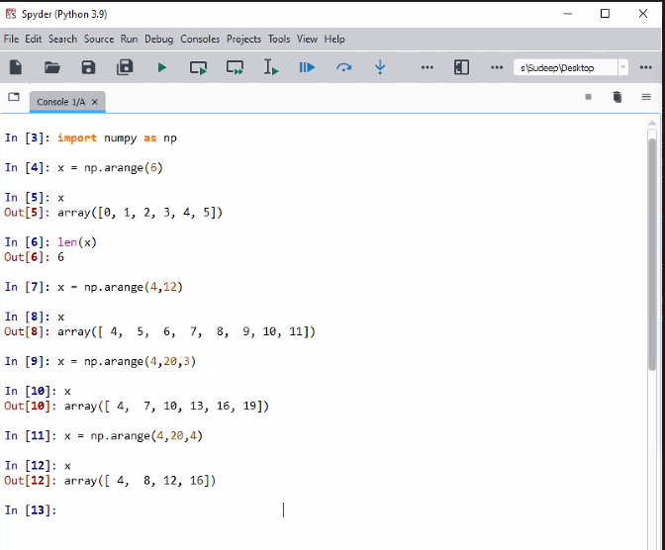

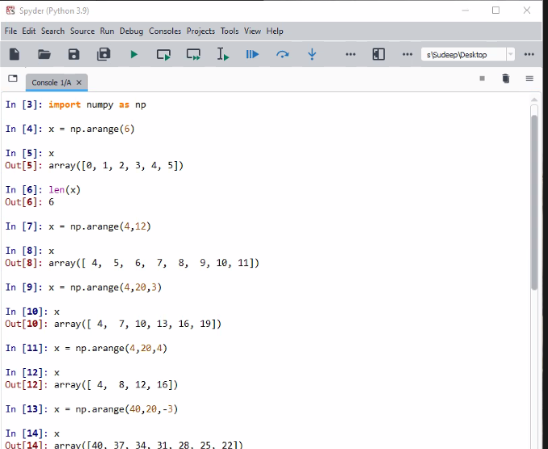

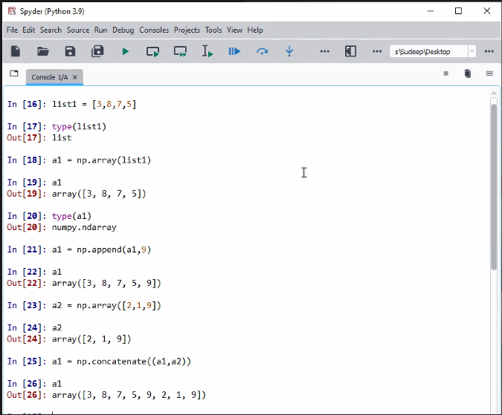

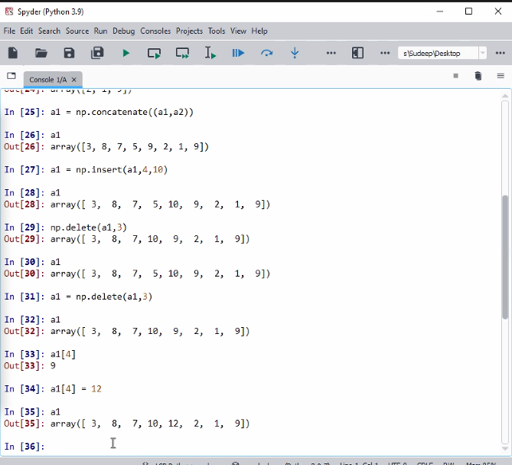

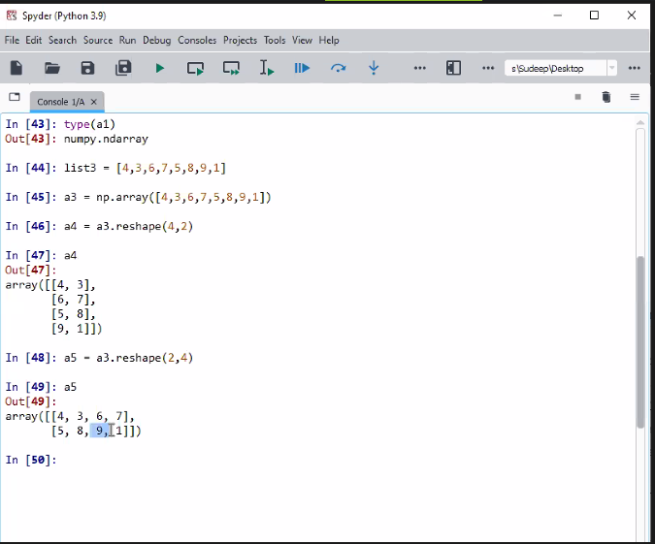

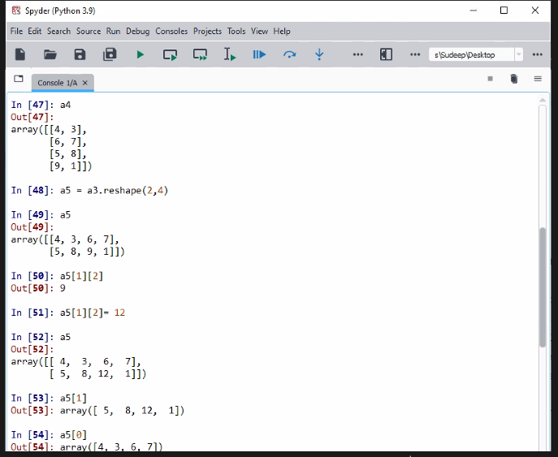

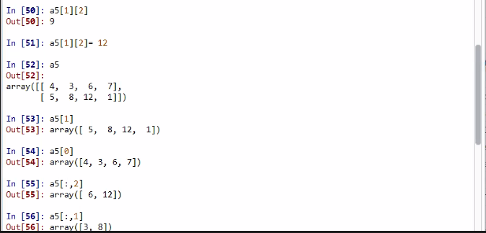

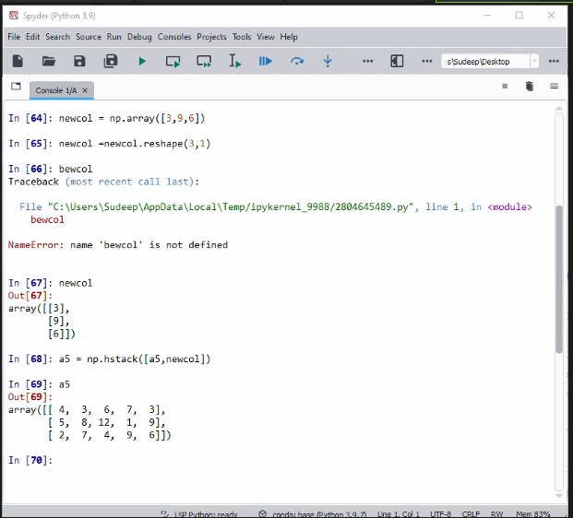

newrow = [2,7,4,9]a5 = np.vstack([a5,newrow])

newcol = np.array([3,9,6])newcol =newcol.reshape(3,1)

a5 = np.hstack([a5,newcol])

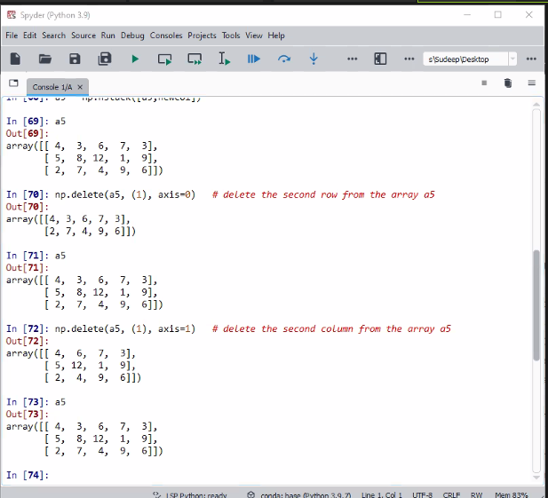

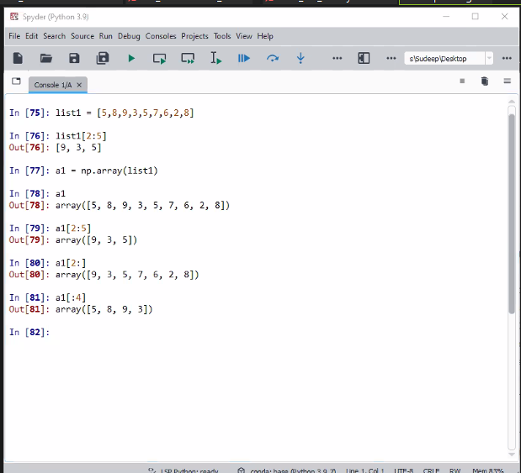

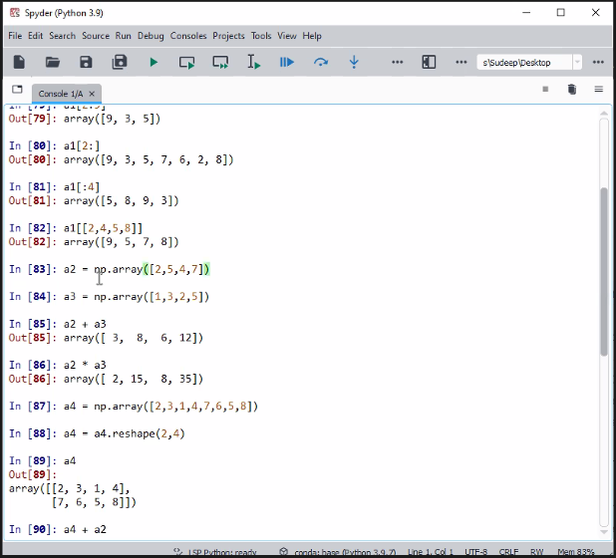

list1 = [5,8,9,3,5,7,6,2,8]

a1 = np.array(list1)

a1[[2,4,5,8]]

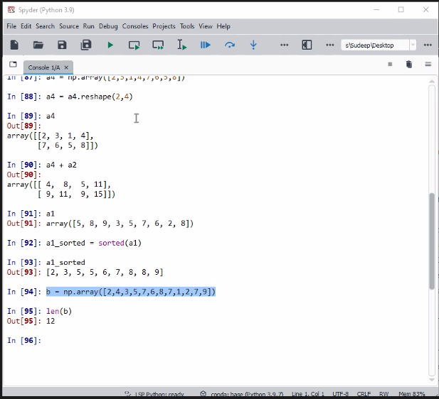



np.where(b1==9)

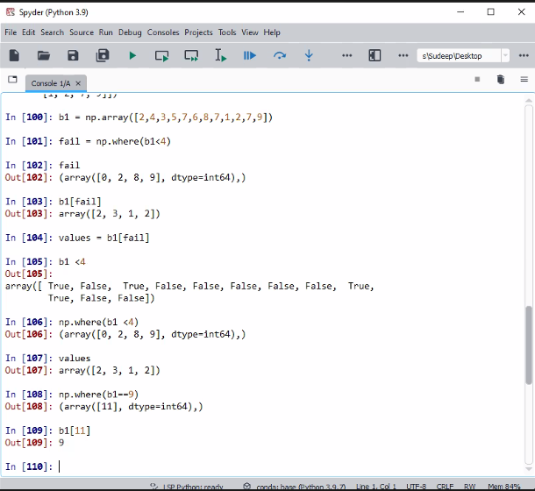

**input to the where command is a logical statement which could be true or false**

**output of the where command is the index or indices where the condition is found to be true**

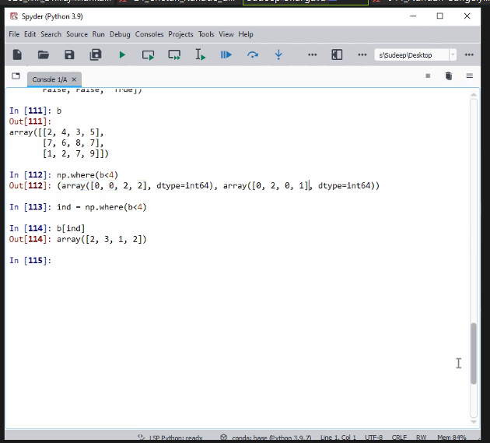

**first array specifies the row index where the condition is found to be true**

**second array specifies the column index where the condition is found to be true**

**first index where the condition is true is row index = 0, column index = 0**

**second index where the condition is true is row index = 0, column index = 2**

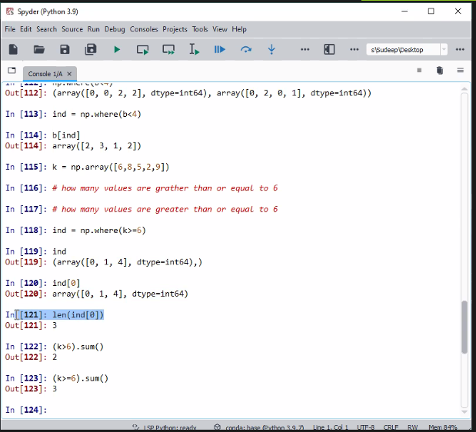

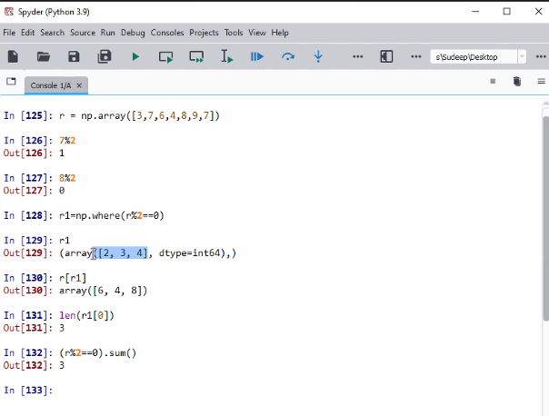

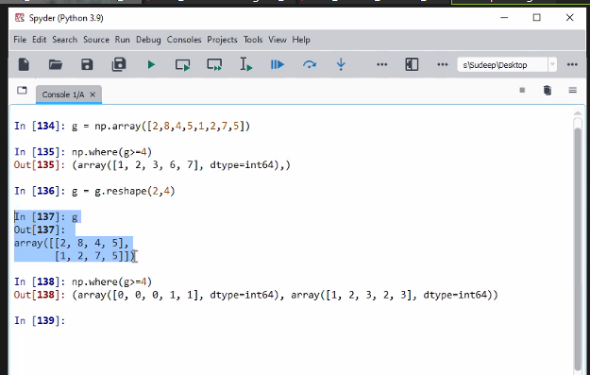

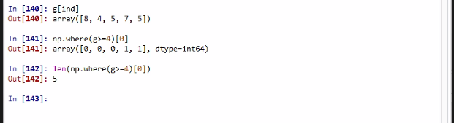

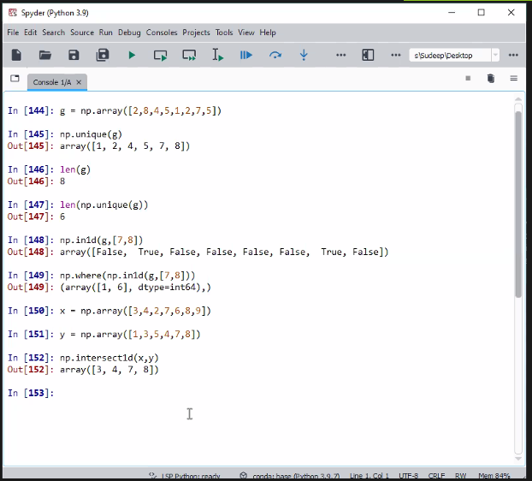

**intersection - AND**

**union – OR**

**np.setdiff1d(x,y)This command gives the exclusive elements of x which are not there in ys**

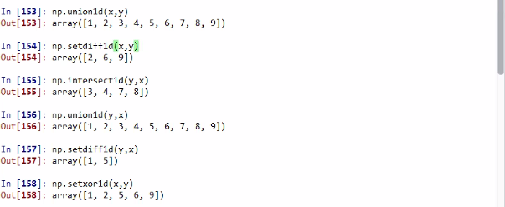

**154 - exclusive elements of x**

**157 - exclusive elements of y**

**158 - exclusive elements of combined x and y**

